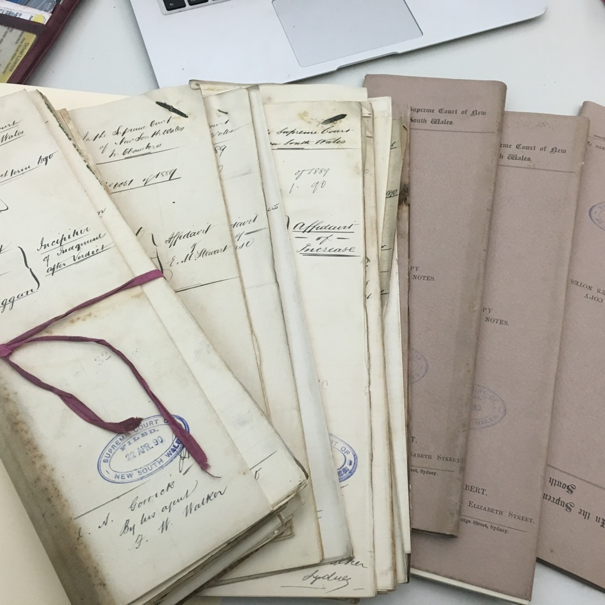
CALL FOR PAPERS

40th Annual Conference of the Australian and New Zealand Law and History Society
(postponed from 2021)

1 – 3 December 2022

Faculty of Law, University of Technology Sydney

Tenuous Histories and Provable Pasts: How Legal Historians Create Knowledge
Due date: Monday 15 August 2022. Email to ANZLHS2022@uts.edu.au
Acceptance: Acceptance will be sent during September.
Programme: The programme will be available by late September.
Format: Primarily face to face but with some online options for presenting and attending.
Registration: Registration will be opened later in the year. Face to face registration will be a flat fee. Options will be available for those joining remotely. We are aware of the difficulties of timezones and cost will depend on the number of sessions chosen.
Keynotes: Keynotes will be advertised in due course.
Accommodation: Options will be made available later in the year.
Further information: As further information becomes available it will be advertised on the Australian and New Zealand Law and History Society’s website: ANZLHS.org. Please sign up to receive notifications of new postings.
CFP Requirements:
Papers are invited on any topic, but we particularly encourage abstracts which address the theme.
Abstracts should be no more than 300 words, accompanied by short bios.
Please indicate if your proposal is contingent on the availability of online participation.
Panels are encouraged.
Conference Theme:
Lawyers and historians have long been aware that what is considered to be knowable and provable is a product of power, history and culture. Legal and historical ‘facts’ are themselves the result of historical processes. Since the 1960s, historians have sought to redress the omissions of state archives, particularly the erasure of First Nations, non-western, queer, female and working class peoples’ perspectives through the use of alternative archives and methods. But what about legal historians? How has legal history taken on board these political challenges? Does legal history – situated in law, with its supposedly ‘more rigorous’ standards of evidence – require more traditional forms of proof than other forms of history? What do we do in our own historical practice when we encounter fragments which suggest a richer history than we can prove: hints as to connections; the roles of shadowy people; lost institutions; unknowable causes; and backstories. How should we think about these fragmentary and unknowable moments, persons, things and connections? What role do speculation and conjecture play? How should we develop theories around the tenuous in legal history?What is required to ‘evidence’ our legal histories? What precisely are the epistemological premises of legal history?

